How to Setup and Use E-Sign Signature Queued Approval
In this example, E-Sign Signature Queued Approval will be set up for Employee Pay Code Pay Rate changes.
Assign E-Sign Approvers
- Go to Microsoft Dynamics GP | Tools | Setup | Auditor | System Settings.
- In the Auditor System Settings window, in the E-Sign Approvers section, mark the Users who will be E-Sign Approvers along with, Message Center, Email (including an Email address), or both.
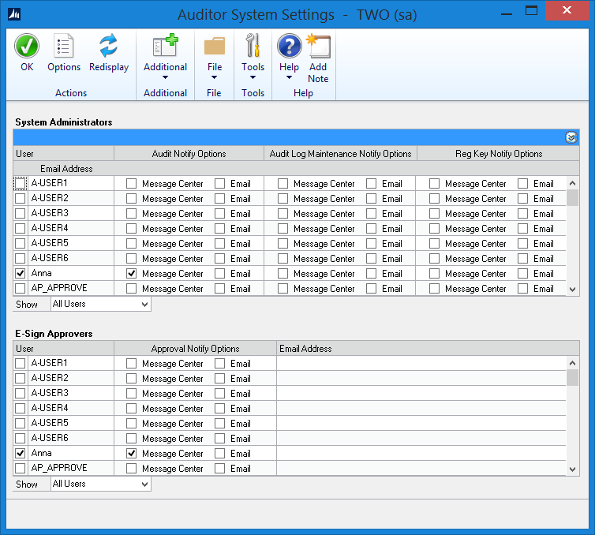
- Click OK.
Setup Pre-Defined Reason Code (Optional)
- Go to Microsoft Dynamics GP | Tools | Setup | Auditor | Reason Codes.
- In the Reason codes window, click the New Reason Group button.
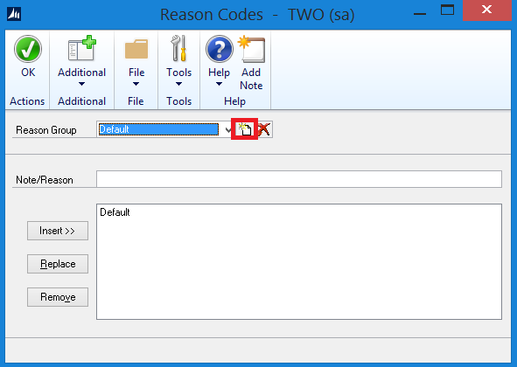
- Enter EmployeePayRate for the Reason Group.
- Enter the Note/Reason, and then click Insert.
- Repeat the step above for any other notes/reasons for an Employee Pay Rate change.
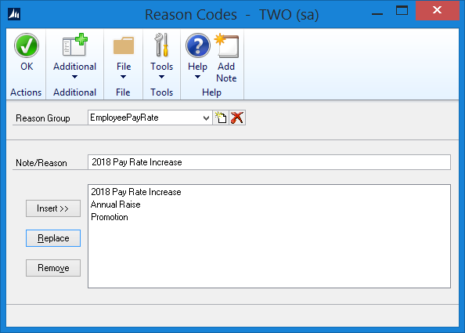
- Click OK.
Create E-Sign Signature
- Go to Microsoft Dynamics GP | Tools | Setup | Auditor | E-Sign Signatures.
- In the E-Sign Signature Definition Maintenance window, enter a Signature Name and Description. For example:
  - Signature Name: Employee_Pay_Rate
  - Description: Pay Rate Changes
- Select if a Reason Code is Required, Optional, or None.
  - In this example, select Optional.
  - Select the EmployeePayRate Reason Code if one was created from steps in Setup Pre-Defined Reason Code section above. Note: You can drill back on the Reason Groups to create pre-defined reasons for the Users who are making the Employee Pay Rate changes.
- Mark Approval Required.
- In the Approver Assignment section, mark which User(s) you want to approve Employee Pay Rate changes.
- In the Company Access section, mark which Company(ies) you want to have access to the E-Sign Signature.
- In the User Access section, mark which User(s) you want to have access to the E-Sign Signature.
- Click Save.
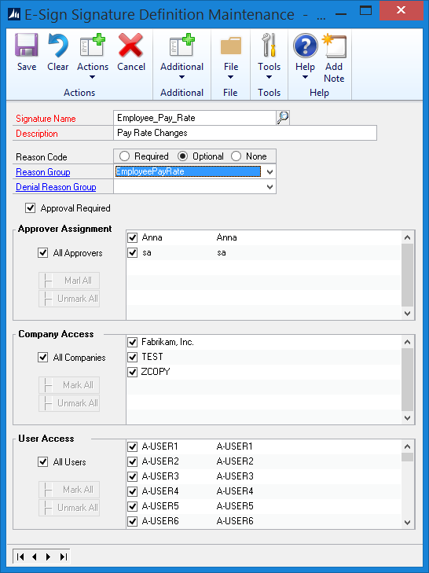
Assign the E-Sign Signature
- Go to Microsoft Dynamics GP | Tools | Setup | Auditor | E-Sign Signature Assignments.
- In the E-Sign Signature Assignment window, click the Add Assignment button.
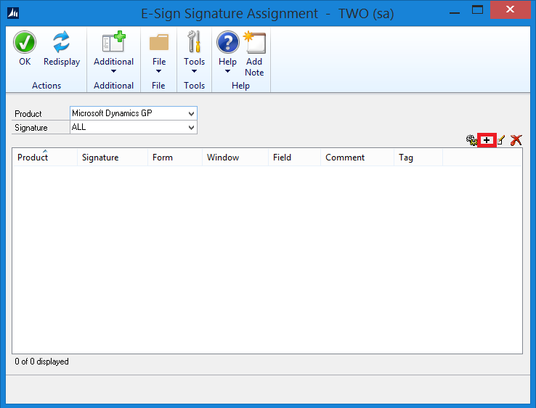
- In the Signature Assignment Wizard Welcome window, click Next.
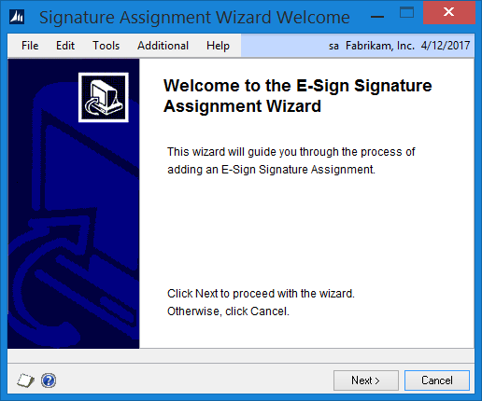
- Click the Signature Name lookup button, select Employee_Pay_Rate, and then click Select.
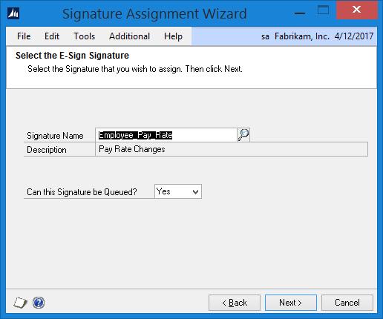
- Click Next.
- Open the window where you would like to assign the Signature to. In this example, go to Cards | Employee | Pay Code.
- Once the window is open, the Signature Assignment Wizard will be updated.
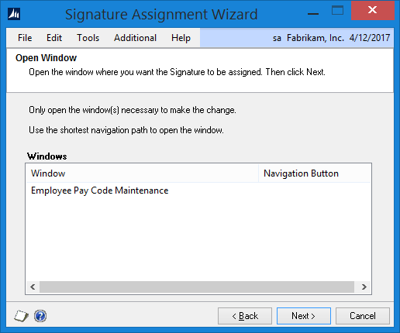
- Click Next.
- Move the cursor to the field you would like to assign the Signature to. In this example, move the cursor to the Pay Rate field and the Signature Assignment Wizard will be updated.
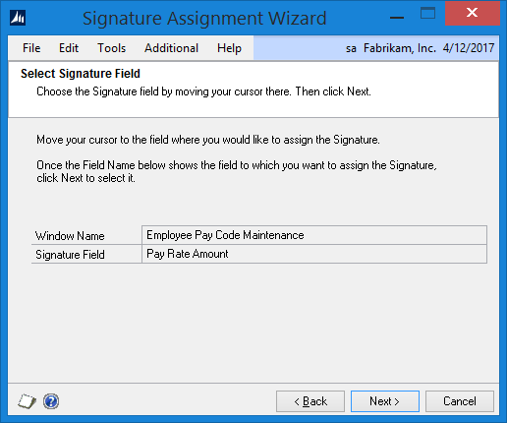
- Click Next.
- Click the button that is used to save the information on the window. In this example, click the Save button in the Employee Pay Code Maintenance window.
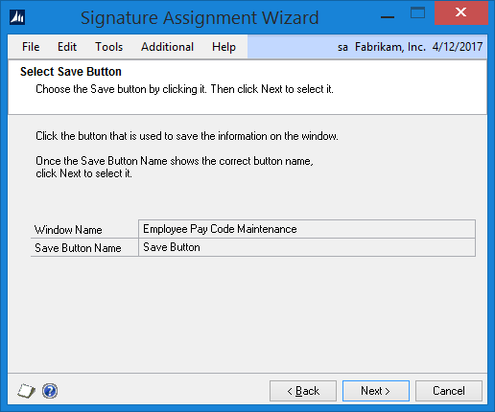
- Click Next.
- Select each field that must be selected to display the record in the window.
  - In this example, put the cursor in the Employee ID field, and then click Select.
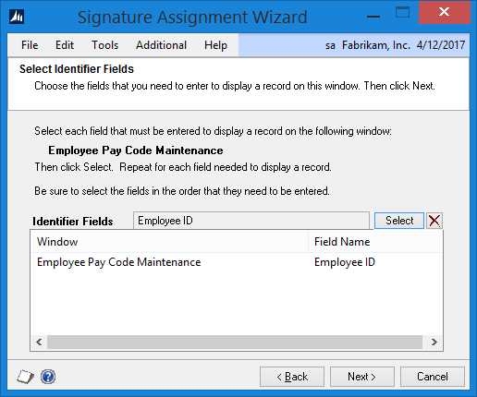
  - Put the cursor in the in the Pay Code field, and then click Select.
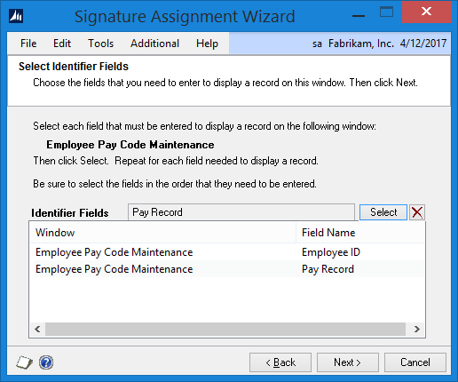
- Click Next.
- Select each field in the window that you want the Approver to see when the Signature is requested. In this example, put your cursor in the following fields and then click the Select button for each of them. Note: If a field is grayed out, use the scrolling arrows to pull up a record with the field available.
  - Employee ID
  - Pay Code
  - Pay Rate
  - Pay Period
  - Base on Pay Code
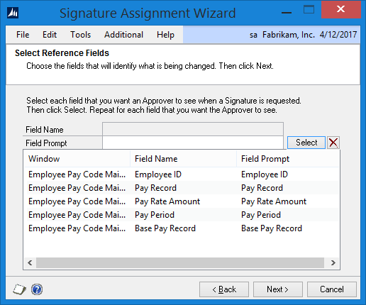
- Click Next.
- Review the information.
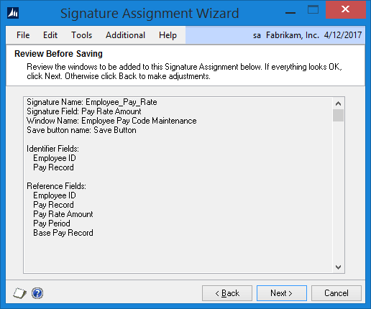
- Click Next.
- Mark to Display the Signature Assignment, and then click Finish.

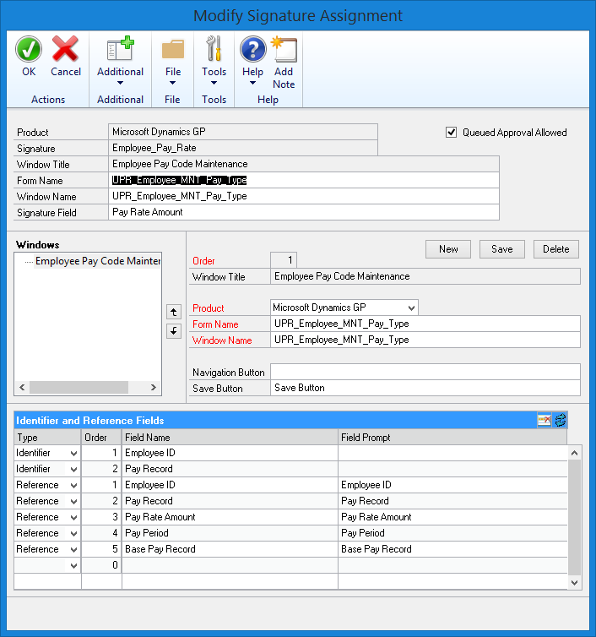
- Click OK.
Test the E-Sign Signature Queued Approval
LESSONUSER1 makes a Pay Rate change in the Employee Pay Code Maintenance window
- Log into Microsoft Dynamics GP (GP) as a User who has access to make Pay Rate changes. In this example, I am going to log in as LESSONUSER1.
- Go to Cards | Payroll | Pay Code.
- In the Employee Pay Code Maintenance window, select ACKE0001 for the Employee ID.
- Select SALY for the Pay Code.
- Change the Pay Rate value from $22,500.00 to $25,000.00, and then tab off the field.
- In the E-Sign Approval Needed window, enter LESSONUSER1’s password.
- Select or enter a Reason for the change.
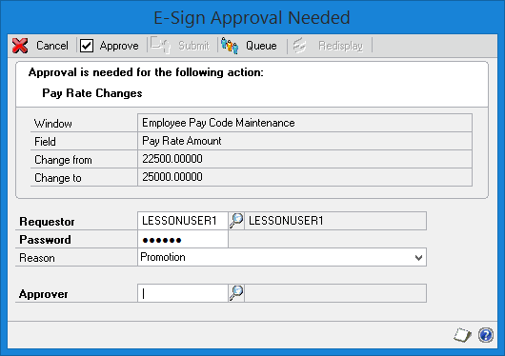
- Click the Approver lookup button.
- In the Approvers window, select a User to approve the change and then click Select. In this example, select Anna, and then click Select.
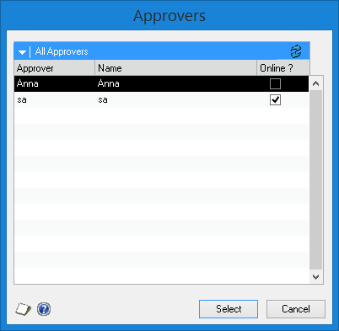
- In the E-Sign Approval Needed window, click Queue.
Note: If Anna was nearby, you could click Approve and Anna could enter their password on your machine and the change would be approved.
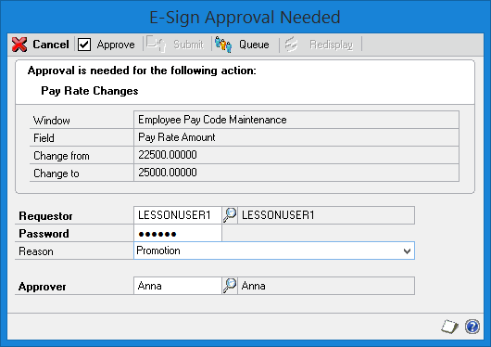
- Click OK.
- Close the Employee Pay Code Maintenance window.
Anna approves the Pay Rate change request
- Log into Microsoft Dynamics GP.
- The E-Sign Pending Approval Requests window will open.
- In the E-Sign Pending Approval Requests window, double click on the item.
- In the E-Sign Complete Approval window, view the information. Note: To see the reference fields, click the blue expansion button.
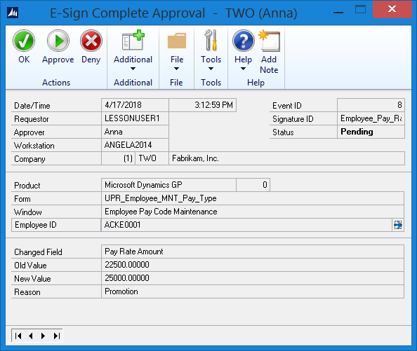
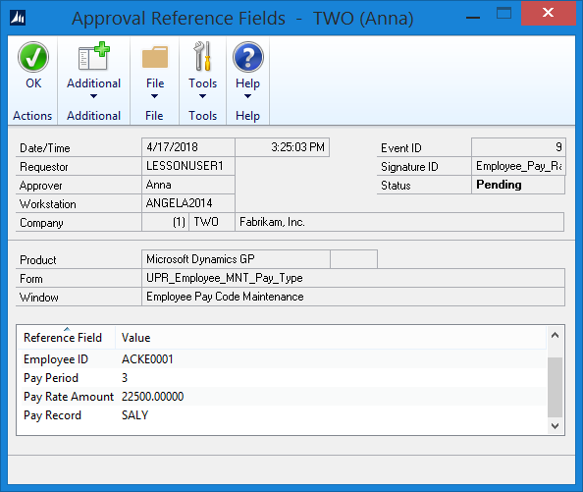
- Click Approve.
- Enter Anna’s password, and then click Approve.
- Click OK.
- Close the E-Sign Pending Approval Requests window.
LESSONUSER1 accepts approval
- In the E-Sign Request Status window, click Apply to apply the changes that LESSONUSER1 requested and that Anna approved.
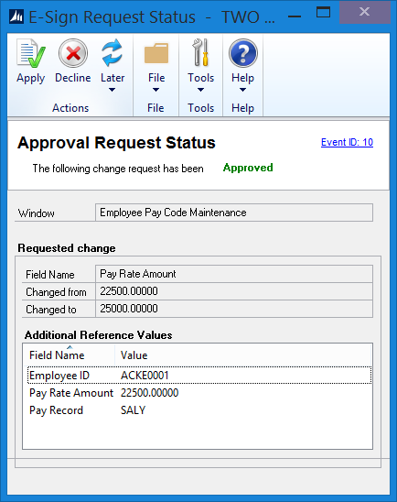
- Click OK to the Process Complete message.

