How to setup and use E-Sign Signature Approvals on a Window button
In this example, E-Sign Signature Approval will be assigned to the Save button in the Customer Maintenance window.
Assign E-Sign Approvers
- Go to Microsoft Dynamics GP | Tools | Setup | Auditor | System Settings.
- In the Auditor System Settings window, in the E-Sign Approvers section, mark the Users who will be E-Sign Approvers along with, Message Center, Email (including an Email address), or both.
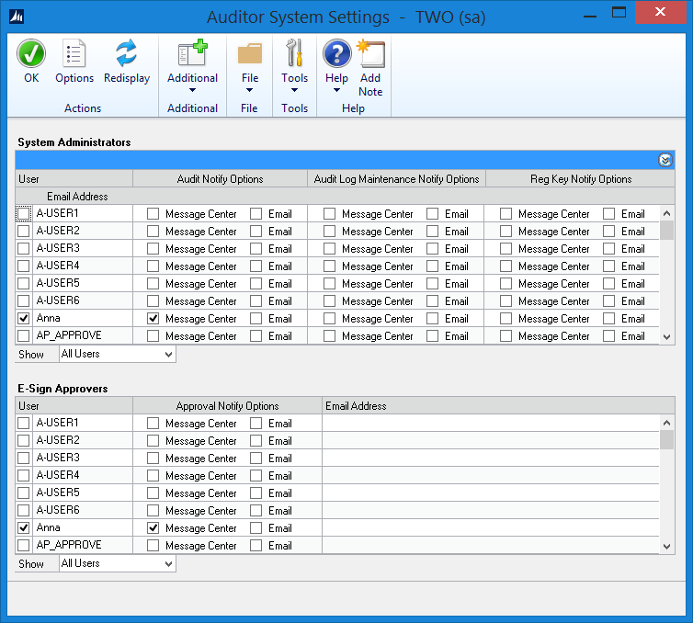
- Click OK.
Setup Pre-Defined Reason Code (Optional)
- Go to Microsoft Dynamics GP | Tools | Setup | Auditor | Reason Codes.
- In the Reason codes window, click the New Reason Group button.
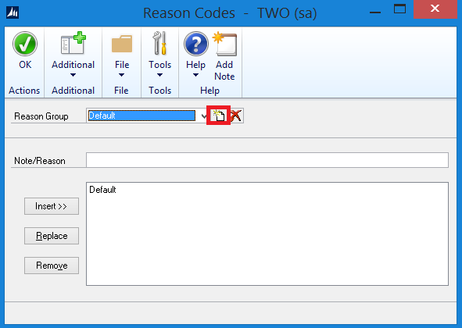
- Enter Customer for the Reason Group.
- Enter the Note/Reason, and then click Insert.
- Repeat the step above for any other notes/reasons for a Customer change.
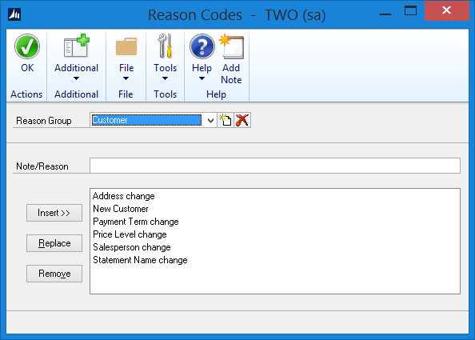
- Click OK.
Create E-Sign Signature
- Go to Microsoft Dynamics GP | Tools | Setup | Auditor | E-Sign Signatures.
- In the E-Sign Signature Definition Maintenance window, enter a Signature Name and Description. For example:
  - Signature Name: Customer_Save_Button
  - Description: Customer Save Button
- Select if a Reason Code is Required, Optional, or None.
  - In this example, select Optional.
  - Select the Customer Reason Code if one was created from steps in Setup Pre-Defined Reason Code section above. Note: You can drill back on the Reason Groups to create pre-defined reasons for the Users who are making the Customer additions or changes.
- Mark Approval Required.
- In the Approver Assignment section, mark which User(s) you want to approve Customer additions or changes.
- In the Company Access section, mark which Company(ies) you want to have access to the E-Sign Signature.
- In the User Access section, mark which User(s) you want to have access to the E-Sign Signature.
- Click Save.
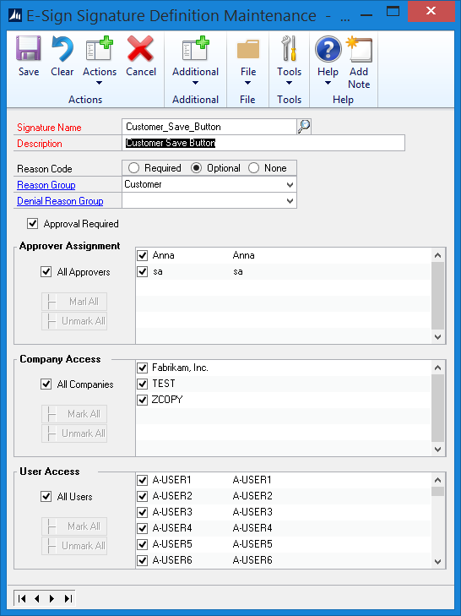
Assign the E-Sign Signature
- Go to Microsoft Dynamics GP | Tools | Setup | Auditor | E-Sign Signature Assignments.
- In the E-Sign Signature Assignment window, click the Add Assignment button.
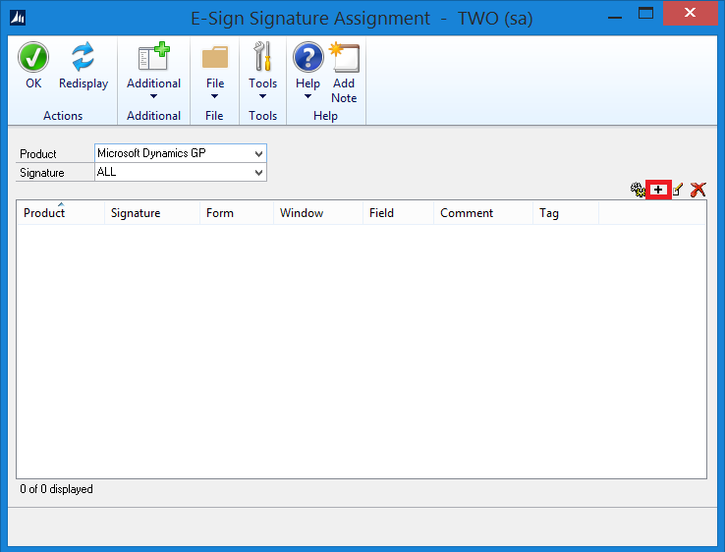
- In the Signature Assignment Wizard Welcome window, click Next.
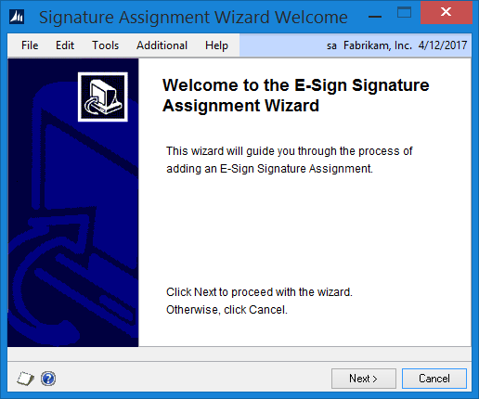
- Click the Signature Name lookup button, select Customer_Save_Button, and then click Select.
- Select No for Can this Signature be Queued? Note: E-Sign Signatures on Buttons must be approved before the User can continue in Microsoft Dynamics GP.
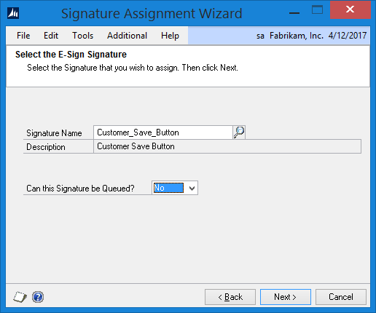
- Click Next.
- Open the window where you would like to assign the Signature to. In this example, go to Cards | Sales | Customer.
- Once the window is open, the Signature Assignment Wizard will be updated.
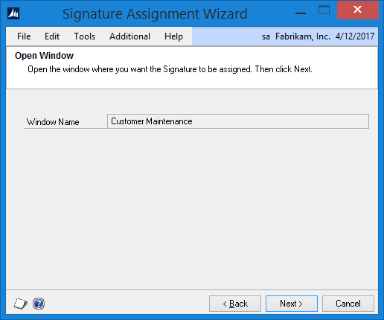
- Click Next.
- Move the cursor to the field you would like to assign the Signature to. In this example, click the Save button and the Signature Assignment Wizard will be updated.
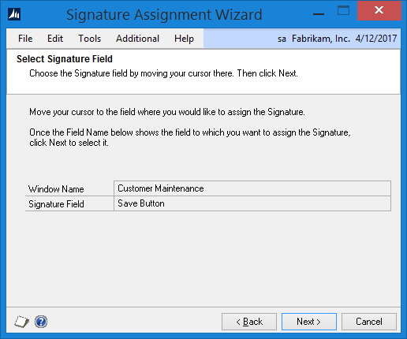

Note: If Yes was selected for the option of Can this Signature be Queued, the warning message below will appear at this time. Click Yes to change the setting to a non-queued E-Sign Signature Approval.

If you want to use a push button field as the Signature Field, then this signature cannot be queued. You have chosen to allow queued approvals. Would you like to change this setting?

- Click Next.
- Select each field in the window that you want the Approver to see when the Signature is requested. In this example, put your cursor in the following fields and then click the Select button for each of them. Note: If a field is grayed out, use the scrolling arrows to pull up a record with the field available.
  - Customer ID
  - Name
  - Statement Name
  - Class ID
  - Address ID
  - Contact
  - Address
  - Phone 1
  - Salesperson ID
  - Payment Terms
  - Price Level
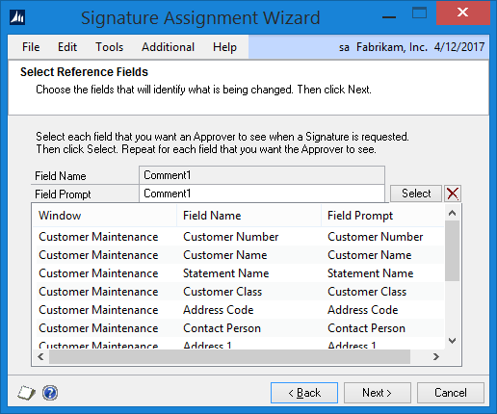
- Click Next.
- Review the information.
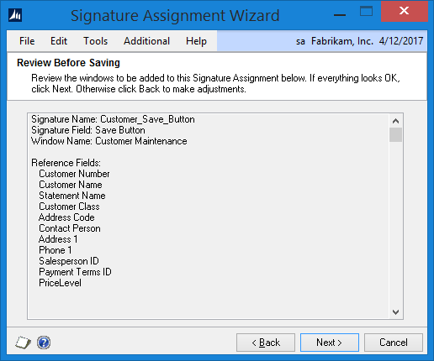
- Click Next.
- Mark to Display the Signature Assignment, and then click Finish.

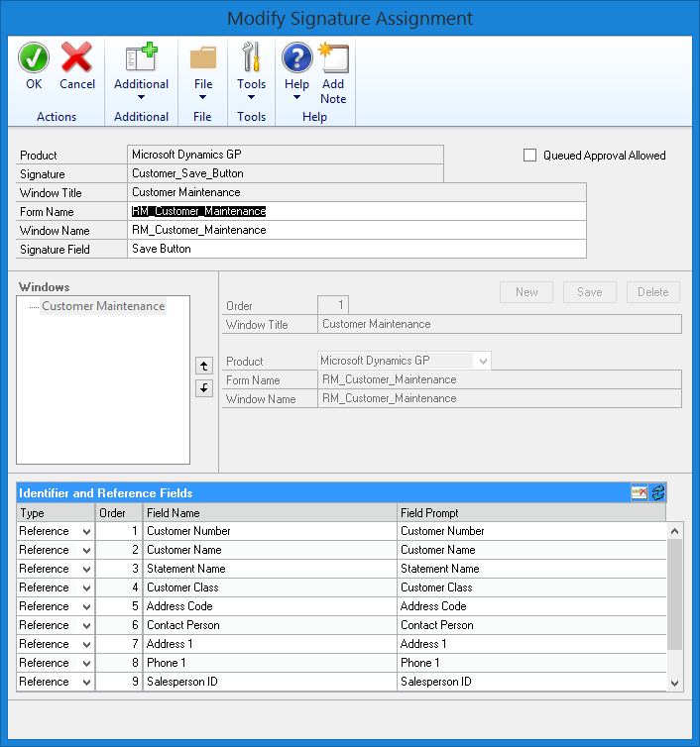
- Click OK.
Test the E-Sign Signature Approval Button
LESSONUSER1 adds a new Customer record.
- Log into Microsoft Dynamics GP as a User who has access to add Customers. In this example, I am going to log in as LESSONUSER1.
- Go to Cards | Sales | Customer.
- In this example, enter the following information in the Customer Maintenance window.
  - Customer ID, Name, Short Name, and Statement Name: TEST
  - Class ID: USA-MNWI-T4
  - Address ID: PRIMARY
  - Contact: Sue Johnson
  - Address: One Microsoft Way
  - City: Redmond
  - State: WA
  - ZIP Code: 98052
  - Phone: (555) 555-5555
  - Price Level: Retail
  - Comment 1: Contact Sue or Mary.
- Click Save.
- In the E-Sign Approval Needed window, enter LESSONUSER1’s password.
- Select or enter a reason for the change.
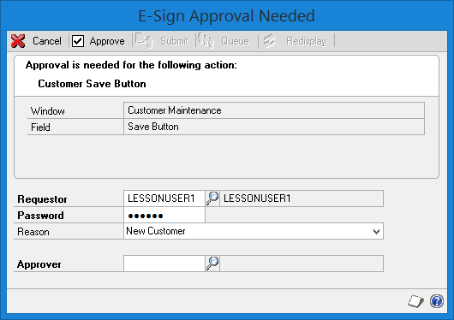
- Click the Approver lookup button.
- In the Approvers window, select a User to approve the change and then click Select. In this example, select Anna, and then click Select.
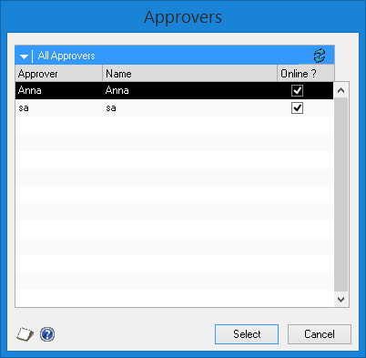
- In the E-Sign Approval Needed window, click Submit.
Note: If Anna was nearby, you could click Approve and Anna could enter their password on your machine and the change would be approved.
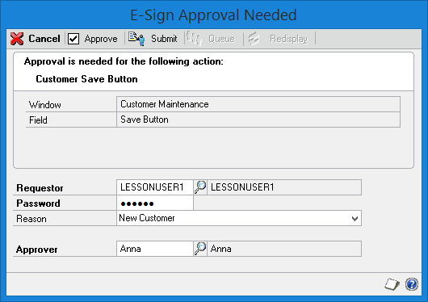
Anna approves the new Customer request
- Anna is currently logged into Microsoft Dynamics GP.
- The E-Sign Pending Approval Requests window will open.
- In the E-Sign Pending Approval Requests window, double click on the item.
- In the E-Sign Complete Approval window, view the information. Note: To see the reference fields, click the blue expansion button.
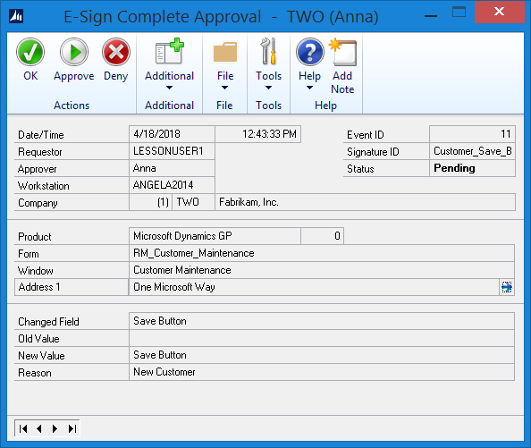
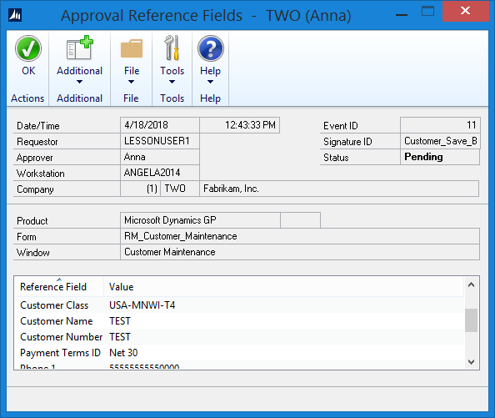
- Click Approve.
- Enter Anna’s password, and then click Approve.
- Click OK.
- Close the E-Sign Pending Approval Requests window.
LESSONUSER1 accepts approval
- In the E-Sign Approval Needed window, click Redisplay, and then click OK to accept the Approval from Anna.
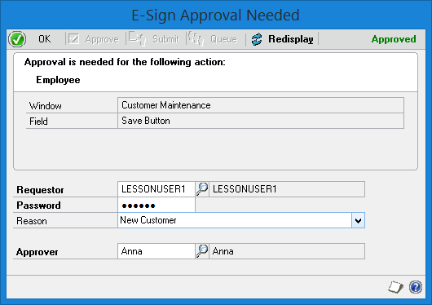
- In the Customer Maintenance window, click Save, and then close the window.

